|  |  |  |  |
| --- | --- | --- | --- |
| Group | Rf value Red | Rf value Blue | Rf value Yellow |
|  |  |  |  |
|  |  |  |  |
|  |  |  |  |
|  |  |  |  |
|  |  |  |  |
|  |  |  |  |
|  |  |  |  |
|  |  |  |  |
|  |  |  |  |
|  |  |  |  |
|  |  |  |  |
| Class Average |  |  |  |

**Chromatography Lab Write Up**

**Name:**

Known Data Table

|  |  |  |  |  |  |
| --- | --- | --- | --- | --- | --- |
|  | Solvent Front | Red #40 | Blue # 1 | Yellow #5 | Solvent |
| Distance (mm) |  |  |  |  | Salt Water |
| Distance (mm) |  |  |  |  | Alcohol |

Unknown Data Table

|  |  |  |  |  |  |
| --- | --- | --- | --- | --- | --- |
|  | Solvent Front | Red #40 | Blue # 1 | Yellow #5 | Solvent |
| Distance (mm) |  |  |  |  | Salt Water |
| Distance (mm) |  |  |  |  | Alcohol |

Salt Water Results

Calculations

Salt Water

**Rf  Red #40 Rf Blue #1 Rf Yellow #1**

Alcohol

**Rf  Red #40 Rf Blue #1 Rf Yellow #1**

% Error from Class Average of Salt Water

**Red #40 Blue #1 Yellow #1**

**Unknown Results- Calculate the Rf value(s) of any spots that developed. Compare them to the known Rf values and to identify the dye(s) present. Name the dye(s) in the unknown.**

Chromatography Post Lab Questions

Three overhead markers were analyzed using salt water as the solvent. The result is shown below. Mark each of the following statements as TRUE or FALSE. Explain why the false statements are false.

G3 = Green 3 B1 =Blue 1 R40 = Red 40 R3= Red 3

____The blue pen contains at least 2 different components.  
  
_____ The blue pen contains only 2 components.  
  
_____ The red pen definitely contains Red 40.  
  
_____ The red pen may contain Red 40.  
  
_____ Green 3 is not present in any of the pens.  
  
_____ The purple pen has one dye in common with the red pen, and one with the blue pen.  
  
_____ The purplish dye is more polar than either Green 3 or Blue 1  
  
_____ We would expect to find FD & C Dyes in the pens.

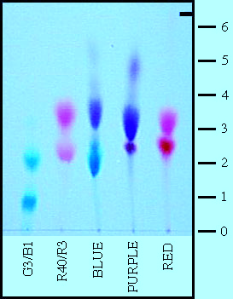

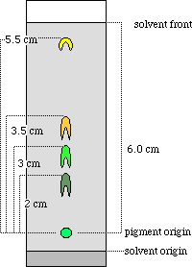 Calculate the Rf value of indicated spot.

A sample of brown dye from a lollipop is placed at the origin on a strip of a chromatography plate. The solvent front moves 9.0 cm from the origin. A blue component of the dye moves 7.5 cm and a red component 5.2 cm in the same time. Calculate the *R*f values of the two components.

Consider the diagram of thin-layer chromatography of three food colors in Figure 6.2.

**a** Why must the level of the solvent be lower than the origin where spots of the mixture are originally placed?

**b** Why are *R*f values always less than one?